IT Project

University of Cincinnati

**Efficient E-Commerce Solutions: Crafting a Seamless Shopping Experience with User-Centric Features**

By Pavan Kumar Radhala

# Abstract

This research project explores two key aspects of e-commerce web application development: the fact that it is focused on user-oriented features and uses of Python as the best programming language. In the study, emphasis is on the improving usability which sheds light on role the accounts and the purchase history play in enhanced user engagement and satisfaction. The research focuses on the evaluation of those features to found out the effect on users’ behavior and choices. It aims at controlling the best strategies to maximize the e-commerce sites. Moreover, the test takes a look at Python's applicability for e-commerce creation taking care of such factors as scalability, expressiveness, and ease of implementation. By means of scrutinizing the mentioned considerations, the research intends to detect the strong side and reveals the weak side of the Python for the issue of e-commerce web applications development. The results show the necessity of human-centered design thinking in creating a rich and handy interface, and at the same time, they make Python visible as an advanced and adaptive programming language for implementing sophisticated e-commerce schemes. Finally, this study gives tangible contributions to the ongoing literature as it gives suggestions for the methods and approaches that improve the user experience in e-commerce platforms and what programming language should be used and for.

***Keywords:*** *e-commerce, user-centric features, Python, web application development, user experience.*

Table of Contents

Abstract 2

Chapter 1: Introduction 5

1.1 Research Questions 7

1.2 Background/Context 7

1.3 Aim & Objectives 8

Chapter 2: Literature Review 9

2.1 Development Approaches and Technologies in E-commerce Websites 10

2.2 Integration of E-commerce Applications with Business Systems 11

2.3 Web Development Frameworks for E-commerce 12

2.4 Agile Methodologies and DevOps Culture in E-commerce Development 13

Chapter 3: Methodology 16

3.1 Research Design 16

3.2 Application Development Approach 17

3.3 Entity Relationship Diagram 18

3.4 Use Case Diagram 19

3.5 Data Flow 20

3.6 Development Process 21

3.7 Iterations and Updates 22

3.8 Evaluation Metrics 23

3.9 Ethical Considerations 23

3.10 Limitations 23

Chapter 4: Results and Findings 25

Chapter 5: Discussion and Limitations 30

Chapter 6: Conclusions, Recommendations, and Future Works 33

References 35

**List of Figures**

Figure 1 ERD Diagram 18

Figure 2 User Case Diagram 19

Figure 3 Data Flow Diagram 20

Figure 4 Home Page of Ecommerce Store 25

Figure 5 Categories Page 26

Figure 6 Customer Login and Registration Page 26

Figure 7 User Cart after Adding a Product 27

Figure 8 Checkout Page 28

Figure 9 Order Placed and all List of Orders 28

Figure 10 Admin Panel 29

# Chapter 1: Introduction

Creating an effective e-commerce solution targeting users to immerse themselves in online shopping effortlessly allows them to enjoy a hassle-free shopping experience (Arora et al., 2019). This project was about developing a simple e-commerce website in which users could view different products, admire various products, and finally proceed to the payment, paying attention to the security of their payment. Users' profile with shopping history was part of the website structure to simplify user experience and create personalized shopping (Dhavala et al., 2023). Through user-oriented design and functionality, our purpose was to set a ground for the e-commerce store that can accommodate the needs and likes of consumers, thus increasing brand loyalty and customer retention.

The rapidly growing popularity of online shopping requires proper e-commerce platforms (Arora et al., 2019). Although many online shopping sites have been established, demand remains for a simple yet powerful tool where users can view the products on display and add them to their virtual carts as they purchase. Low engagement and loyalty by users directly result from poor user experience because many existing platforms need to offer personalized accounts for each individual or order history features (Dhavala et al., 2023). Moreover, specific platforms must be more complex and flexible to provide an impeccable shopping process. In this regard, this study aims to develop and deploy a simple e-commerce web app using one Python framework. The objective is to offer an efficient and safe shopping platform, integrating elements like user accounts and transaction history that improve the overall satisfaction level on users' behalf.

This research adds to literatures on online e-commerce networks by suggesting a new method of designing and developing a quickly operational, however rich, functional web platform based on a Python framework. Amid numerous studies concentrating on high-end e-commerce services, this study will contribute to the need for a straightforward platform targeting users' needs. Adding user accounts and order history elements increases the value of literature already developed, which underlines that users' engagement matters a lot as engaging them leads to their retention within the competitive e-commerce setting. In addition, the availability of Python frameworks speaks to how this language is flexible and effective in building viable yet scalable solutions (Arora et al., 2019). The research is therefore assumed to offer a fundamental yet all-encompassing e-commerce solution that can eventually act as part and parcel or as a basis for continuous improvements.

With the advent of online trading, our project presents an essential aspect for establishing e-commerce services that should be user-oriented (Nayak & Panda, 2024). Establishing a successful online retail business calls for an easy and pleasant shopping experience, and this research fills in the gap. As e-commerce, the success of a start-up or any business that wants to exist in such a platform is dependent on design user-centricity and efficacy (Dhavala et al., 2023). Despite attempting to satisfy all customer needs, it is only sometimes possible for e-commerce providers. Prioritizing the features that benefit a user experience, such as having personal accounts or tracking order history, shows how well this research complies with current market trends while contributing towards future sustainability efforts by online entrepreneurs (Nayak & Panda, 2024). The solutions proposed through the research are a compromise between too simple and too complicated, as the platform has to be intuitive and streamlined enough for more people across a wide range of professions to use. Ultimately, this study provides an essential framework for shaping a new path of e-commerce development while driving customer satisfaction not as one among many factors but instead identifying it as a principal determinant factoring in competitive markets.

## 1.1 Research Questions

* How can the integration of user accounts and order history features enhance the overall user experience in an e-commerce web application?
* What is the comparative effectiveness of Python as a programming language for e-commerce web application development, considering factors such as scalability, versatility, and ease of implementation?

## 1.2 Background/Context

The internet trade has been known for its dynamic nature over the recent years; now, the major area of focus in this sector is these smooth and easy-to-use shopping experiences. It is observed that consumers in their large numbers prefer to use the internet not only for their browsing needs but for their shopping needs as well. Therefore, the surge in efficiency of electronic commerce systems is inevitable. While abundant possibilities exist, it is not always the case that existing platforms are easy to navigate, function correctly, and are user-friendly. Users often end up getting discouraged (Dhavala et al., 2023). While the challenges of the e-commerce industry are increasing day by day that's why it's getting very necessary to build e-commerce solutions which are user-oriented rather than sell-oriented. Through the utilization technology and user interface design benefits, it is possible for the businesses to generate the shop rooms which are interactive and appealing in nature and which are also crucial in motivating the prospective consumers and increasing shop rates (Nayak & Panda, 2024).

## 1.3 Aim & Objectives

The primary theme of this project is to make an online shopping platform that show focus on the user-orientation and elements of the design, this eventually result on making the shopping experience very smooth for users. The purpose was to bring to birth and put into real life use the platform that had all the attributes of browsing products, integrating the accounts of the users and order history in order to make customers personalize their shopping; secure payment processing with encryption and authentication protocols; the platform optimized for responsiveness and compatibility across numerous gadgets; and evaluating the capability of the e-commerce solution for usability or convenience to the users. Mainly, the attempt was success in achieving these objectives to develop powerful and well-performing e-commerce platform which meets the needs and expectations of the modern online users.

# Chapter 2: Literature Review

The research on e-commerce website development consists of different approaches and technologies that typically target creating a fast and user-friendly online shopping environment. These new technologies have become subjects of modern studies on the use of tool sets like React, HTML5, CSS3, Bootstrap 4, node.js, and JSON for the user-responsive and visually appealing e-commerce design (Huynh, 2020). User experience on mobile devices has been the focus and ensuring that browsing and shopping experiences are consistent across all the devices is the key. Further, research has gone into the analysis and development of e-commerce web applications following a client-server pattern, and has also experimented with frontend technologies like Bootstrap, JavaScript, and CSS, along with backend frameworks such as Django (Tyagi et al., 2022). The payment gateway integration and advanced features like time tracking for user engagement have been investigated for making interaction between user and platform better and hence differentiating platforms in a competitive market (Tyagi et. al, 2022). Moreover, literature has delved into particular difficulties including those that the COVID-19 pandemic has presented such as through internet based solutions for examples, for accessibility to essential shopping without having to visit a store (Khan et al., 2020). In this digital revolution, e-commerce applications with business systems integration has become a serious consideration that will facilitate numerous processes and achieve higher level of efficiency (Gaedke and Turowski, 2000). Also, the significance of web development frameworks such as Laravel in the sense that it reduces the time and process of making a website and optimizes its performance has been mentioned (Yadav et al., 2019). With the e-commerce scenario undergoing constant change, we need to discover inventive strategies and technologies that assist to overcome the prevailing issues and meet the modern requirements of the users and businesses at the same time.

## 2.1 Development Approaches and Technologies in E-commerce Websites

Huynh (2020) took up the initiative of developing a responsive and user-friendly e-commerce website utilizing the contemporary and advanced technologies like React, HTML5, CSS3, bootstrap 4, node.Js, and JSON. Emphasis was mainly on how the number of users of smart phones was on the rise. There was product list with images that could be sorted, filtered by size and added to cart. Responsive tests, functionality tests, and browser compatibility checks were performed in the implemented project; the results were positive showing that the implemented project succeeded. The application was seen as simple, charming, implemented and it met the needs of an online shop.

In fact, Tyagi et al. (2022) concentrated on the alysis and development of an e-commerce web application built on a client-server architecture. For the frontend, Bootstrap 4.0, JavaScript, and CSS were used alongside Django was used in the backend operation and API development. The research was designed with a web-based application in mind, targeting users to buy basic household goods from their premises. The application implemented the PayPal ‘payment gateway’, also included a tracker, which could give status updates as to shipping. TimeMejs was a unique characteristic; the JavaScript library which would keep a check on the time spent by the user on the application and reward them with credit points for use in checkout. This approach sought to increase the level of user interactions and value creation for the business which made the e-commerce platform different from competitors.

Khan et al. (2020) discussed about the design and development of such an e-commerce based online web application which is exclusively designed and developed for the COVID-19 pandemic situation. Aware of the problems connected with conventional grocery shopping, the research suggested an Internet shop as a remedy. The internet platform enabled one to shop for necessary items from wherever they were found lying on a computer or a smartphone and did not have to visit a grocery store. Systems was equipped with an admin dashboard for controlling that in the context of availability of products as well as a user panel requiring a Gmail verification before the shopping could be performed. Within the global pandemic, the online grocery shop was located as the time saving, preventing, and consumer-friendly different from the physical shopping.

## 2.2 Integration of E-commerce Applications with Business Systems

With regard to Gaedke and Turowski (2000), their study is devoted to the integration of web-based e-commerce applications with business applications systems. The authors point at the World Wide Web which has changed from being just the medium for knowledge change to a home for more and more number of ecommerce applications. Since organizations sell their products and services over the web everyone uses the web to inter-operate their heterogeneous business application systems. The study proposes a generic integration layer implemented using an object-oriented approach and the WebComposition Mark-up Language as an attempt improve the development process. The aim is to support reuse code as well as design which allows communication amongst legacy business application system on an abstract level. This technique improves performance and lowers expenditure related to the creation of new products, finding common ground between rough reality-oriented web implementation models and fine-grained services. Tahir et al. (2021) investigate the creation and implementation of Progressive Web Apps (PWAs) using the Angular framework, and Service Worker for PWA multimedia distribution in e-commerce solutions. With reference to the rapid evolution involving e-commerce in the economic growth in Indonesia, the study integrates PWA technology for a combination of Angular for user interface construction, Angularfire library for server linkage, as well as Service Worker for enhanced website performance through diverse network conditions. The authors perform performance testing and analysis, comparing how different systems perform, those that have service worker and those that do not have it, measuring the response time, throughput, and latency. The findings show that the PWA technology is fast and efficient, thereby being able to implement e-commerce systems; analyzes how to improve performance of web systems in contemporary settings of information technologies.

## 2.3 Web Development Frameworks for E-commerce

The work by Yadav et al. (2019) represents one of the pieces that enriches the literature to the pertinent questions and technologies discussed above. Considering the fact that the modern age relies on the internet to grow businesses, the names authors stress the importance of web development frameworks. They stress that frameworks take matters into their hands and develop websites in a way that is not tiring, quick and effective. The paper highlights the significance of frameworks for addressing the challenges linked with long duration of developing websites. The Laravel framework as a free and open-source PHP framework is reviewed as an efficient approach to e-commerce websites construction that is preferred to other frameworks. The study acknowledges that Laravel plays a key role in timeous website development process that is convenient to such a rapidly changing and innovative technological environment. The importance of integrating web-based applications into business systems is the topic of interest by Gaedke and Turowski, with the insistence of the need for somekind of generic integration layer. In their paper, Tahir et al. present details regarding PWA technology implementation for e-commerce systems, going about the advantages of utilizing Angular and Service Worker. Yadav et al. present information on the application of Laravel PHP framework for high-efficient e-commerce website development pointing out its benefits compared to other internet technology that develops rapidly. As a whole, these studies produce a general picture of various methods and innovations implemented in a rapidly changing e-commerce environment of application development.

The visual and UI design of e-commerce websites becomes an acute issue, which threatens the global industrialists and business professionals addressed by Ramamurthy et al. (2019). Within the developed scenario, the primary factor that differentiates one vendor from another is the speed of online shopping portals, which also determines the ease of use. The need of excessive exploration of web designing especially the high speed usability that is applied is aimed at perfecting the electronic commerce websites. The following makes sense, and the technology introduced by the authors is that in the web design one of the latest development in term of Web Assembly (WASM), performance and is critical to present a significantly better visual impression, usability, and better runtime performance of e-commerce websites. The proposed endeavor seeks to develop an efficient electronic commerce website built using wasm that will have a good database design coupled with easy navigation and secure as well as fast runtime in order to overcome user issues.

## 2.4 Agile Methodologies and DevOps Culture in E-commerce Development

Leaving aside the pros and cons of DevOps culture and agile methodologies used in e-commerce web app development, Govil et al. (2020) consider the methods and approaches of applying it further. The article is however able to identify that the two can help to inspire/motivate IT industries to achieve business goals in greater measure possibly; hence, it can be realized that the study realizes that two motivates IT industries to achieve greater business objectives. One of the prominent characteristics of Agile is evolution. By definition, evolution here implies that the teams working on it can prioritize work, deliver prototypes, and increase the visibility of software development. In contrast to Agile which focuses of agile processes at the work level, in DevOps there is more emphasis on cooperation between development and operation teams in order to promote fast development in projects where speed is one of the most critical issues. The authors accentuate the simultaneous flexibility of Agile and DevOps, which can easily be adopted by different branches of the software industry, from the realm of traditional business software to internet applications. In nuances of the specific sphere of e-commerce applications, the paper clarifies a number of functional facets of these methodologies and processes. The 2019 research by Ramamurthy et al. relate to the turn of electronic commerce websites optimization through Web Assembly implementation, a technology believed to contribute to better user conditions. Contrastingly, Govil et al. focus on the synergies between Agile methods and culture DevOps tendencies; thus, such synergies find appropriate application within the expansive dynamic landscape of e-commerce web apps. Along with furthering the debate on using technology and methods to improve the design, functionality, and performance of e-commerce sites in general these two studies bring invaluable additions to it. With each industry looking for novel ways of meeting user requirements and responding to business needs, these studies provide suggestions that could shape e-commerce web application development in the future.

The literature review gives us an insight into numerous methods, technologies, and techniques that have been used in the development of e-commerce websites. The scientists have exploited the latest back end and front end technologies, as well as the incorporation of the advanced features and payment gateways, to deliver better user interfaces and, simplify the operations. The combination of e-commerce applications with business systems brings the hope that it would ultimately produce better efficiency, a streamlined process and smooth transactions. Besides, the usage of web development framework like Laravel has been very helpful in making the development of the website process easy and the performance of the website optimized. With business shifting toward the internet market adoption, agile methodologies and DevOps culture are taking an upper hand. This ensures the institutions remain in a co-ordinated and flexible position. To conclude, more investigation is required next into future technologies such as PWAs and WASMs to keep up with the amended users’ needs and preferences. The information benefits businesses in two ways. Firstly, they can build platforms that are perfectly equipped to meet the wants and needs of digital consumers and stay ahead of competition.

# Chapter 3: Methodology

The methodology section explains the process followed while developing the e-commerce application discussed in this research. It offers the knowledge of the research arrangement, software development mechanism, as well as the applied tools in the building and evaluting of the app. The development process is tailored to achieve the study goals, pinpointing the research questions and using the existing literature and best practices in e-commerce website design as its guide. Moreover, this section is designed to explain the reasons for choosing the research design and the software development methodology which is assumed to be followed throughout the project, ensuring that the application development process will be systematic and comprehensive.

## 3.1 Research Design

The study design for this project is based on software application development process with existing procedures and those documented in previous literature in the field of e-commerce website development. Taking the key points from the literature review, project is aimed at combining user-centric functionality and features with the e-commerce application to make the whole shopping process better. This design practice follows a structured and systematic development structure oriented on well-known standards and methods.

## 3.2 Application Development Approach

Agile is the selected software development methodology to be used in this project and the Kanban board for dividing the tasks into the spills will be its key feature. Agile methodologies are applied to solo projects easily because of their ability to be adaptive, flexible, and iterative. The Kanban board simplifies task management and progress tracking thus it helps in having a code that is well written. Through adopting Agile doctrines, the project aims to stay in a dynamic and adaptive development platform that allows to iterate and refine efficiently the e-commerce solution.

## 3.3 Entity Relationship Diagram

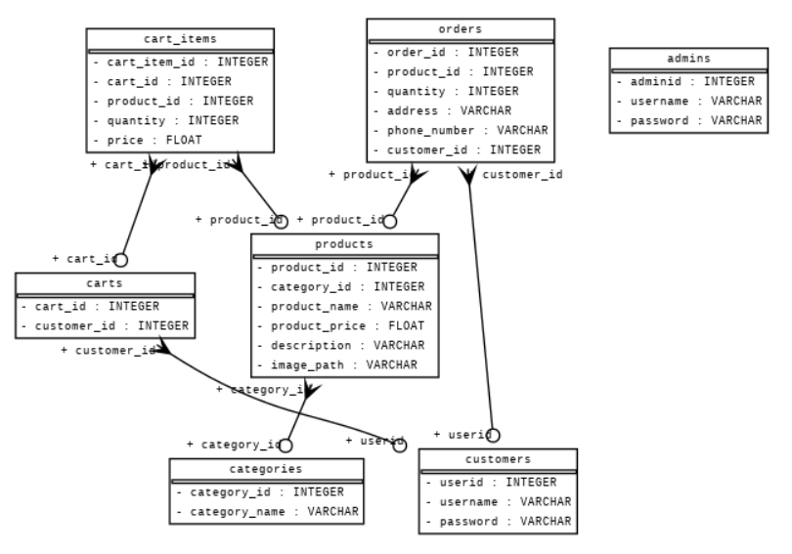

Figure 1 ERD Diagram

The Entity-Relationship Diagram (ERD or E-R Diagram) has been used for depicting the structure relationships between the entities in the database that is to be used in an e-commerce app. The ERD visualized from the proposed models shows the main entities and relations among them. The system consists of few entities like Customer and Admin, each associated with a unique identifier like ID. These entities have username and password attributes utilized for authentication purposes. Furthermore, the Category scum is divided into items by categories, and the unique identifier of each category is (category_id), while the category name is (category_name). Product entity of the system signifies individual units available for sale, under the category data and having a unique product ID ( product_id). The product title, price, description and the image source code are conserved within this logical entity. Besides, Order would log orders clientele place along with the items purchased, delivery address, and contact information. Payments form chains of interconnections between customers associated with a product. Furthermore, these two entities control the course of runtime for purchases as customers pick up multiple products for later purchase. These entities build relationships with customers and items in which they can identify the products in a customer's shopping cart. In a nutshell, the ERD serves a number of the purposes that will support the efficient management of data within an e-commerce application development.

## 3.4 Use Case Diagram

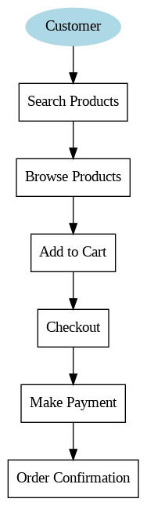

Figure 2 User Case Diagram

The diagram is a depiction of all the possible actors/use cases and their interrelationships in the online store application. The Customer can be traced at the "system center" in this diagram, and is the primary actor within it. Shown as boxes each with rectangular shape, they bring out different function or action which is the application properties. The sequence starts with "Customer" by looking for goods, so Search Products use case also comes into play. The next screen will hold the customers briefed on the results of searches using "Search For Products". The customer starts their journey by finding a few items they would like to get. By clicking on the "Add to Cart" button they can add the items to their virtual cart. After adding the items to cart, the customer enters the checkout that particular use case which is called checkout. After a customer checked all the products and all their needed info, he selects a payment method, consequently it goes to the "Make Payment" use case. The next use case is confirmed when the customer hit the Pay Now button on the screen and the order is entailed to the system with an order confirmation use case. The use case diagram describes a sequential flow invoked by actions representing typical interactions a customer would have with the e-commerce application from searching for products to their payment, complete with a purchase. This graphical representation provides clarity on the overall system orients everyone involved in the inter-component interactions.

## 3.5 Data Flow

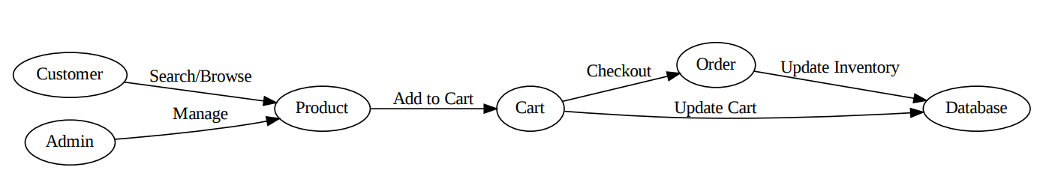

Figure 3 Data Flow Diagram

DFD (Data Flow Diagram) depicts the data flow in the e-commerce application, taking into consideration the emphasis of the information flow among the various entities and components. Essentially, the 'Customer' and 'Admin' are external agents, which respectively designate the users who interact with the application, and employ the application system. The 'Customer' entity is represented by activities such as browsing through the products and making product related searches. On the other hand, the 'Admin' perform product management activities. These external parties will interact with the process of 'selling' (which involves managing of products and showcasing them). In case a customer is adding a product into their 'Cart' section, it is generating an updated data store for 'Cart' containing all the products selected for the purchase. A checkout later, the 'Cart' data is sent to the 'Order', which then updates the 'Database' to reflect the current inventory and to record the transaction. This dynamic process involves a series of interactions to fulfil customer purposes to browse, select, and buy products as well as administrative process for managing inventory and product selection for sellers. The DFD demonstrates the fundamental data exchanges and interaction; it is therefore the plan that depicts the functions of the e-commerce application as well as the processes of data management.

## 3.6 Development Process

The programming process for the e- Commerce application began with the computer language Python, Flask, and SQLAlchemy. It is worth noting that Python was the most ways utilized programming language because of its adaptability and sturdiness. Flask, micro web frameworks for Python, made easy the establishment of web routes, capturing, and processing HTTP requests and responses. SQLAlchemy, ORM (Object-Relational Mapping) library was used for interaction with the SQLite database, modelling database, and executing database queries. The coding process followed the Agile approach principles: Kanban, in particular and in it cards with tasks were used to track the progress and it was iteratively applied for details. Every single task actually stood for certain a function or a feature of the application like user authentication, product management, and order processing. Collaboration was not involving this solo project, whereas development process had only a single individual involved in it. Adherence to coding standards formed a part of the development process in order to maintain uniformity as well as readability. This involves compliance with Python's PEP 8 style guide for code formatting, use of meaningful variable and function names, and code documentation where necessary. This project by nature was unfolding through continuous loops, so that each cycle allowed for adjusting and perfecting the features in accordance with the feedback gathered from users, testers and surveys.

## 3.7 Iterations and Updates

Development of the software process was without exception characterized by a series of draws, reductions and modifications due to the User feedback and the results of testing. The development procedure concentrated on solving the key limitations of usability drawn from the consumer reaction and testing. These update, helped to identify the areas that need to be improved in the app, and helped to provide a good user experience. In addition, these updates also enabled us to foresee and fix any problems that may arise. The unique feature was the iterative approach of the procedure which opened up the possibility for performance upgrading and guaranteed that the final product could satisfy the demands of customers completely.

## 3.8 Evaluation Metrics

The metrics that were considered in analyzing the performance of the software are the response time of the system, level of user satisfaction, efficiency gains and overall usability. The performance of the system was evaluated via response times duration, page loading duration and database query execution time. The level of satisfaction among the audience was determined through peer reviews. The efficiency was measured by comparing the executed record against the specifications defined in the benchmark and the industry standards.

## 3.9 Ethical Considerations

Information confidentiality, security, and user consent were vital during software development, which receive our full attention. Measures were put in place to make sure user data was securely stored and could not be accessed by unauthorized persons. An informed consent on collecting personal and sensitive information was obtained from users and they were given with detailed information about which their data will be used for and is how their data will be protected. Furthermore, conduct of regular risk and compliance checks was undertaken to ensure that ethical standards which were set initially are still adhered to.

## 3.10 Limitations

Besides the time and money restrictions in the course of the developing process of software, we run into resource constraints as well. Hence, due to the lack of resources it became very crucial to emphasize on the features and functionalities, which probably hindered the extent of work and caused the development time to increase. There were still some difficulties which converged towards being innovative but yet professionally realistic that delivered a high standard demanded and specified by the client within the prevailing environment.

# Chapter 4: Results and Findings

This chapter shows the performance of an e-commerce store that developed, highlighting the highlighted points illustrated during the testing and evaluation of the store.

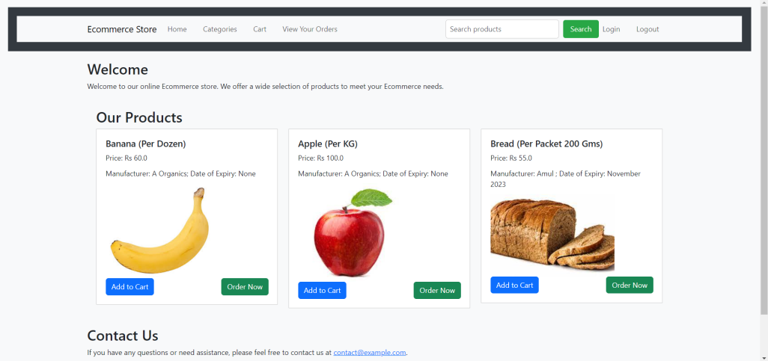

Figure 4 Home Page of Ecommerce Store

Figure 4 displays the home page of the online store has been showed. As examples this page has a top bar with options of Home, Categories, Cart, View your orders, Login, and Logout. The central part of the webpage evidences the available products for purchase, each with an 'Add to Cart' button and a 'Buy Now' button placed next to it. The landing page will be their entry gate into the store where they can make inquirers, but most importantly interact with the store's offerings.

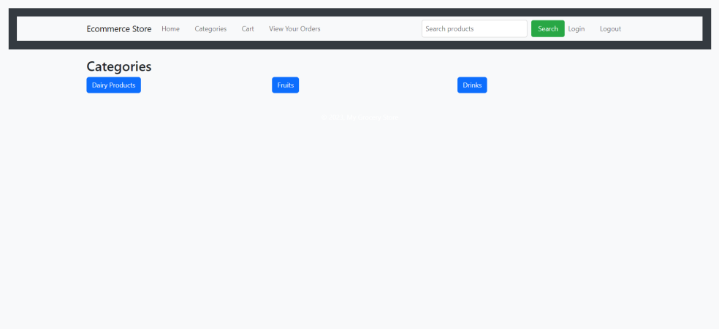

Figure 5 Categories Page

The categories page in the Figure 5 allows the users to navigate through the different categories to find the products they are interested in. This page gives a clear view of the available products categorized, therefore, enabling the customers to directly access their preferred section effortlessly. By means of organizing products into big categories, a customer can easily find exactly what he or she is looking for and, consequently, improve their shopping experience and enlarge the range of a product.

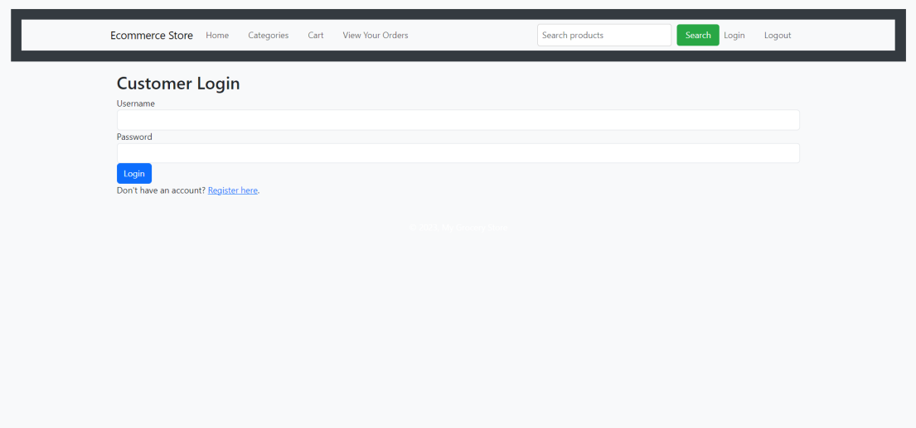

Figure 6 Customer Login and Registration Page

Figure 6 depicts the customer login and signup page acting as a pathway for the users to avail personalized features and account functionalities. This is where prospective users can deposit the needed data, including username and password through account registration. The logged-in existing users can enter a credential page to manage the dashboard, order history, and account settings. It offers a secure and user-friendly login and registration for users, hence improving the user experience on the website.

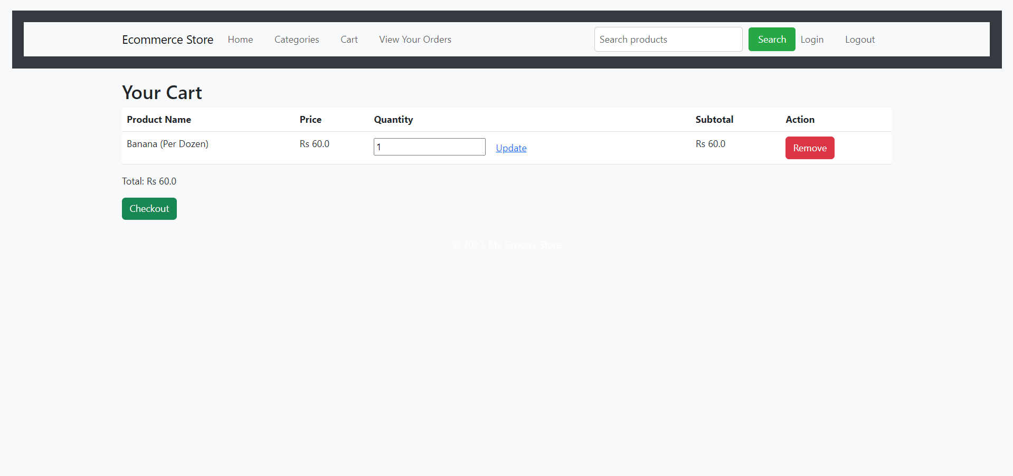

Figure 7 User Cart after Adding a Product

Figure 7 shows the user shopping cart page after the product is selected. This serves as the page for the users where they are presented with a summary of products added to their basket inclusive of product details such as name, price, and quantity. Customers have a chance to double-check their selections, give correct quantities and then move on to the checkout point to finish off their purchase. The cart functionality provides shoppers with the opportunity to quickly manipulate their purchase content, which includes the ability to checkout effortlessly, which ultimately translates to an intuitive and convenient experience.

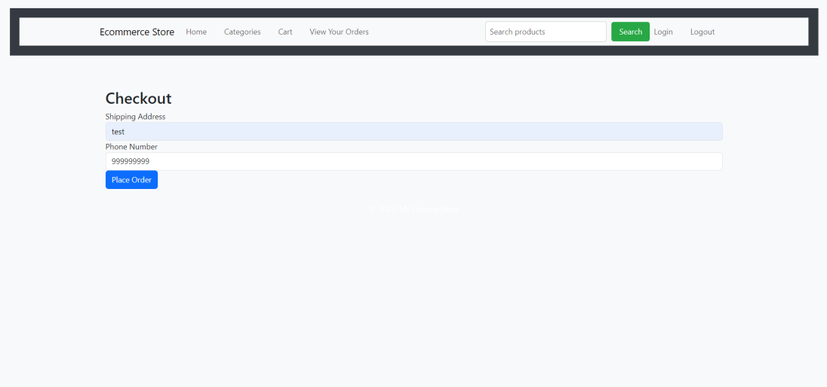

Figure 8 Checkout Page

Figure 8 depicts a checkout page that enables users to complete their purchases by choosing the option that suits them best to proceed with the payment. This step involves collecting and verifying customer information such as shipping details and payment method to facilitate a secure and hassle free purchase. On a shopping cart page, clients can go through their order summary, use any available discount, promo codes or chose payment methods to their taste. The usual checkout page helps reduce the effort on the user's side, as it provides a seamless way to complete the shopping process and obtain their orders efficiently.

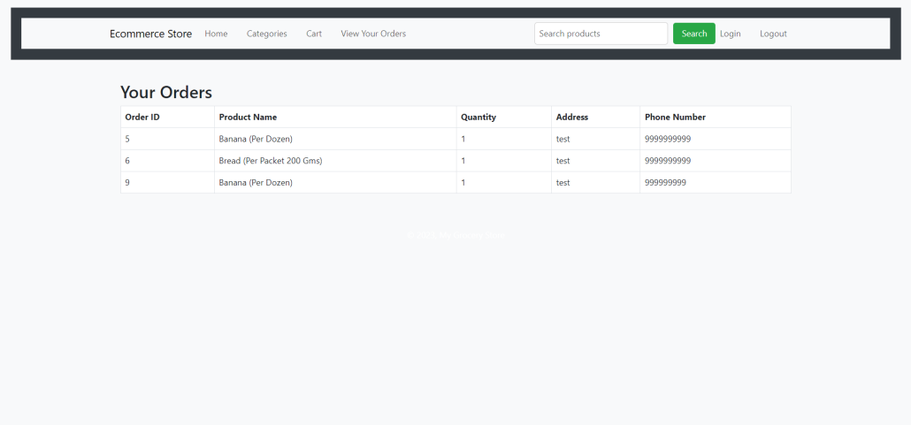

Figure 9 Order Placed and all List of Orders

Figure 9 depicts the order confirmation page after the items are added to the shopping cart. A list of previously placed orders is also shown. In this section users can confirm order completion including a summary of orders and a tentative expected delivery. Also the shoppers might check the array of their previous orders on the list and at the same time observe the condition of their delivery notifications. The order management feature increases the user satisfaction levels and demonstrates the clear achievement of certain goals during the order completion process.

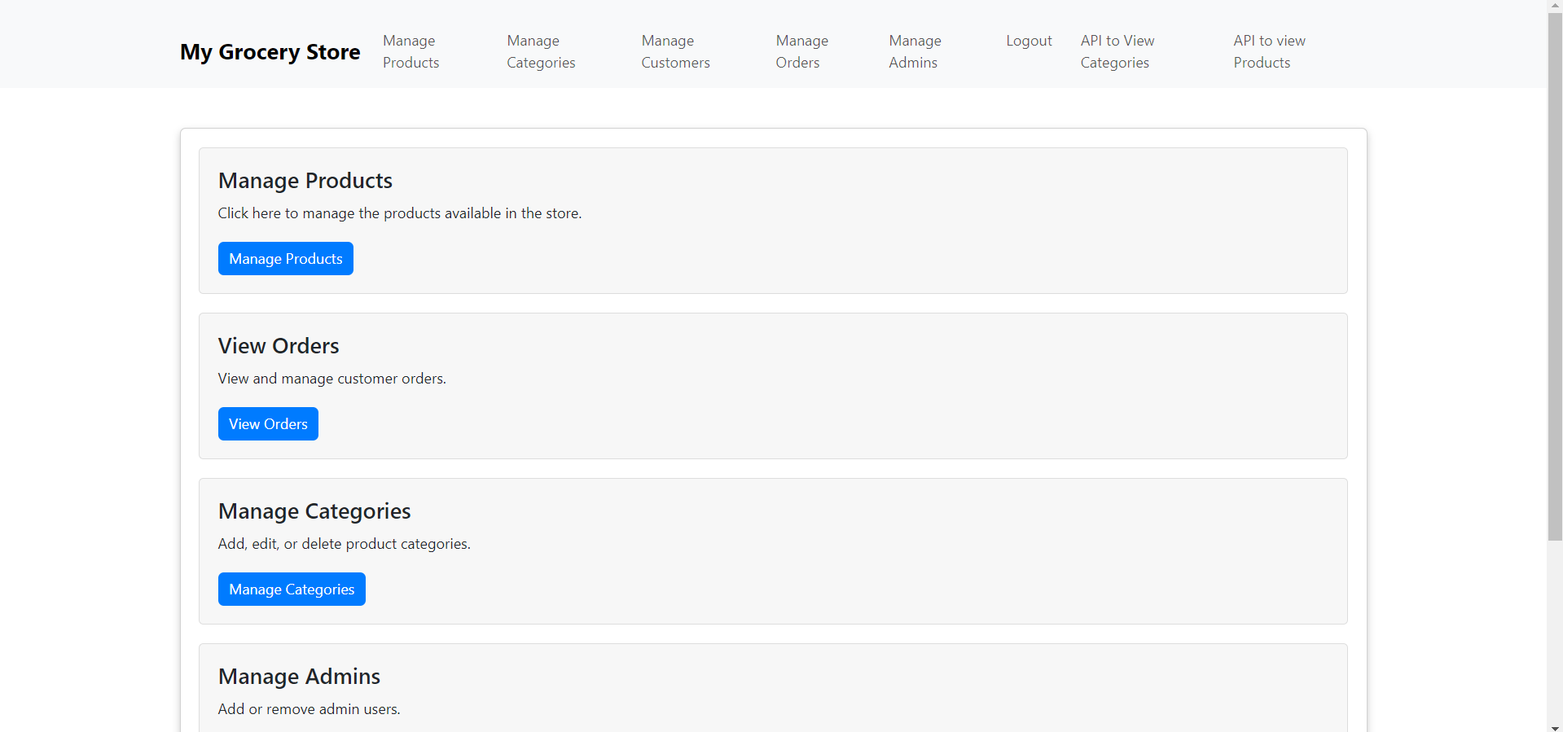

Figure 10 Admin Panel

Fig. 10 presents the admin panel, which empowers administrators by offering different management and administrative instruments. Using the admin dashboard, administrators will essentially be in a position to add products, log orders, see and process users' activity statistics and set the right settings for the whole site. The admin panel is the central control room for operating the e-store, providing business admins the instrument of value addition while efficiently overlooking and maintaining the store.

In this chapter, it is the final result and the conclusions of the chapter, that the implemented main features and uses of the developed e-commerce store are the success. Users will enjoy a comfortably navigated and efficient shopping process, either as customers or store maintainers; the store, therefore, features a friendly and usable interface on the one hand, and an admin panel with a robust functionality on the other. The results indicate that features indeed increase attractiveness of the system to users in terms of increased operational efficiency, secure & secure dealings. Finaly, the results show that the determined e-commerce store is in full operation, and it has been successful to its objectives, which comprise wide-ranging and user–friendly online shopping platform.

# Chapter 5: Discussion and Limitations

The incorporation of the features like user accounts and order history into the web application, functioning as an e-commerce platform, is the major factor that leads to the improvement of the whole customer experience. The smartphone app allows users to create accounts; hence, it can tailor the shopping experience for each user, offering such services as preferred list and order tracking, as well as easing the checkout procedure. User accounts provides a facility of secure storage of data like shipping address etc. as well as wallets, hence the necessity of data entry of these details may be eradicated completely. Apart from that, order history modules bring up past purchase details to consumers to have relationship management and minimize reordering hassles of the favorite items and offer insights into the previous transactions. This integration develops a sense of confidence in and distinctive within the platform, which attract users and develop user engagement and keep them loyal. In addition to this, because of the ability to view and track order history, supply chain transparency, customers also ensure that they comprehend the entire journey to their purchase and are confident while buying. To be able to evaluate the Python language as competitive programing language for e-commerce web application development, we will have to focus on such criteria as scalability, adaptability and ease of use by the developers. Scale-up of Python is due to the powerful infrastructure of libraries and frameworks like Django and Flask which compose a robust ecosystem that enable developers to build highly scalable and efficient web applications. These frameworks provide functions such as ORM (Object-Relational mapping) and routing and templating. These functions serve to ease development processes and allow for structured platforms to be created easily and with a lot of features. Moreover, Python enables the development team to integrate other technological services and solutions into the banking platform and connect it to, for example, payment gateways, and third-party APIs, and data analytics tools. This flexibility takes Python-powered e-commerce apps to the whole new level. It lets them easily implement new business requirements later on, and may enlarge existing user base as a result.

On the other side, Python’s simplicity of implementation makes it a perfect candidate to be used in the development of e-commerce web applications. The infrastructure has a readable and smooth syntax which enables express speed of the prototyping and iteration thus the processes of converting business requirements to function code are more clear and efficient. Python has the added advantage of document belts and live community support, thereby making troubleshooting and fine-tuning problems comparatively easier. Yet it has to be admitted that Python, though very convenient, always has some limitations as, for example, slower execution speed than C++ or Java. This however could be of little trouble for most e-commerce applications. It is good to put this factor in mind early in the development stage as it could be a major concern for high-performance real-time processing projects. Finally, accounting for user spots and order history greatly excites the user’s experience in e-commerce platform and thereby increases users’ connection, trust and loyalty. In the case of e-commerce web applications development you may face the need to choose a programming language, Python is high advantageous one because it provides scalability, wide variety of possible implementations and ease of usage. Through Python's power features, and challenging its shortfalls, web developers can make functional and user friendly e-commerce web applications that users like us always wish for in online shopping. Moreover with the rapid growth in technology and changing user mentality, it will be of cardinal importance for our company to keep pace and be successful on the tough competition terrain.

# Chapter 6: Conclusions, Recommendations, and Future Works

This research project has proved that such user-friendly features are extremely important and ease of use in e-commerce web applications must be considered as a major factor to increase user satisfaction. Students are urged to concentrate on particular features that attract more users, like account provisions, order history because they are directly associated with the growth of user engagement, retention, and satisfaction. Users accounts on the website contributes towards personalization and smooth running of the shopping process. Also order history grants shopper with detailed information thus makes the shopping experience better for the user. Besides, the compared analysis of Python as a programming language for e-commerce web applications creation has shown its high things like as scalability, versatility, convenience of realization. The wealth of the Python environment including frameworks and libraries, which have a few marks of the simple syntax and vast community support make the Python language the better one for building user-friendly and complex e-commerce platform. This research study suggests several means for improving e-commerce web applications and the guidelines are as follows. Firstly, continuous monitoring and the analysis of user behavior are comes along with the data and feedback of them can help to figure out the gaps and rectify them in the user experience. Things like common reports and A/B testing can paint a picture of goals and user behaviors, so the developers can analyze the data and make adjustments if they find the app ineffective. However, infusing the platform with a combo of social media and community driven features such as user reviews and ratings will bring about loyal customers and the establishment of trust among users, which is embodiment of the pub channel to users.

Additionally, future works on this topic could cover cutting edge solutions and approaches in order to solve some of the challenges that will emerge in the e-commerce sector. Likewise, artificial intelligence and machine learning machines could bring personalized recommendation, predictive analytics, and strong fraud protection mechanisms, thereby optimizing e-commerce platforms` functioning and security. Furthermore, incorporating immersive technologies, for example, augmented reality (AR) and virtual reality (VR), can reshape online shopping as consumers will be able to see their prospective products in the environment in the real-world. This capacity will improve the purchase process by allowing consumers to have a better perception of products before making a buying decision. Further, there has been a call to exam conduct ethics in e-commerce which are underlined with data privacy, security, and consent issues. Future research should concentrate on creating the strict data security regulations and safety that would protect users’ information and combat possible cyberattacks and security threats arising out of data breaches. One other factor which gets incorporated in the building of trusts among e-commerce platforms is the transparency of data collection and usage practices. Finally, the research that is outlined above has made it evident that the user-centred design approach and the implementation of the Python programming language in the e-commerce web platform development lead to better user experience. Developers come up with more interactive platforms and user-friendly ones when they have implemented user accounts best order history features which is possible when they are using python that offers scalability and versatility as a solid foundation for building complicated and innovative e-commerce solutions. Digital commerce, now and in the future, will be deciding by the process of constant innovation, understanding consumer demands, and resolving ethical issues.

# References

Huynh, T. (2020). *THE DESIGN AND DEVELOPMENT OF AN E-COMMERCE WEB APPLICATION*. https://www.theseus.fi/bitstream/handle/10024/343090/Huynh_Thao.pdf?sequence=2

Tyagi, S., Yadav, S., Singhal, U., & Chaudhary, H. (2022, July). Analysis and development of e-commerce web application. In 2022 Fifth International Conference on Computational Intelligence and Communication Technologies (CCICT) (pp. 65-72). IEEE.

Khan, M. M., Shams-E-Mofiz, M., & Sharmin, Z. A. (2020). Development of E-Commerce-Based Online Web Application for COVID-19 Pandemic. *IBusiness*, *12*(04), 113–126. https://doi.org/10.4236/ib.2020.124008

Gaedke, M., & Turowski, K. (2000). Integrating Web-based e-commerce applications with business application systems. *Netnomics*, *2*(2), 117–138. https://doi.org/10.1023/a:1019134712734

Tahir, Z., Ilham, A. A., Niswar, M., & Fauzy, A. A. (2021, November). Progressive Web Apps Development and Analysis with Angular Framework and Service Worker for E-Commerce System. In 2021 IEEE International Conference on Computing (ICOCO) (pp. 192-195). IEEE.

Yadav, N., Rajpoot, D. S., & Dhakad, S. K. (2019, November). LARAVEL: a PHP framework for e-commerce website. In 2019 Fifth International Conference on Image Information Processing (ICIIP) (pp. 503-508). IEEE.

Ramamurthy, M., Abishek, D., Logesh, B., & Prasad, S. S. K. (2019). Design of Optimized E-Commerce Website using Web Assembly. *Indian Journal of Science and Technology*, *12*(9), 1–5. https://doi.org/10.17485/ijst/2019/v12i9/141996

Govil, N., Saurakhia, M., Agnihotri, P., Shukla, S., & Agarwal, S. (2020, June). Analyzing the behaviour of applying agile methodologies & DevOps culture in e-commerce web application. In 2020 4th International Conference on Trends in Electronics and Informatics (ICOEI)(48184) (pp. 899-902). IEEE.

Arora, A., Srivastava, A., & Bansal, S. (2019). Business competitive analysis using promoted post detection on social media. *Journal of Retailing and Consumer Services*, *54*, 101941. https://doi.org/10.1016/j.jretconser.2019.101941

Dhavala, G., Sheoran, S., Arya, A., Vajpayee, M., Jain, V., & Shrivastava, D. (2023). Well Being Assistance Chat Application. *International Research Journal on Advanced Science Hub*, *5*(Issue 05S), 496–500. https://doi.org/10.47392/irjash.2023.s066

Nayak, M., & Panda, S. (2024). Online Grocery Recommendation System Implementation Using Python Flask and Machine Learning. *Advancement in Image Processing and Pattern Recognition*, *7*(2), 78–85. http://hbrppublication.com/OJS/index.php/AIPPR/article/view/4753